Project Planning Phase
Project Planning Template (Product Backlog, Sprint Planning, Stories, Story points)

Date | 15 February 2025
Team ID | LTVIP2025TMID32756
Project Name | Pollen’s Profiling:Automated Classification Of Pollen Grains
Maximum Marks | 5 Marks

Product Backlog, Sprint Schedule, and Estimation (4 Marks)
Use the below template to create product backlog and sprint schedule
Sprint | Functional Requirement (Epic) | User Story Number | User Story / Task | Story Points | Priority | Team Members
Sprint-1 | Data Collection | USN-1 | As a user, I can upload pollen grain image from different sources | 3 | High
Sprint-1 | preprocessing | USN-2 | As a user, I can clean segment images for better classification | 2 | High
Sprint-2 | Feature Extraction | USN-3 | As a user, I can extract morphological features from uploaded pollen images | 2 | Medium
Sprint-1 | Model Training | USN-4 | As a user, I can train an ML/DL model using labelled data | 3 | High
Sprint-1 | Classification | USN-5 | As a user, I can classify a give pollen grain into its respective category | 2 | High
Sprint-3 | Result Dashboard | USN-6 | As a user, I can view the classification results and accuracy on a dashboard | 2 | High

Project Tracker, Velocity & Burndown Chart: (4 Marks)
Sprint | Total Story Points | Duration | Sprint Start Date | Sprint End Date (Planned) | Story Points Completed (as on Planned End Date) | Sprint Release Date (Actual)
Sprint-1 | 20 | 6 Days | 05 May 2025 | 10 May 2025 | 20 | 10 May 2025
Sprint-2 | 20 | 6 Days | 12 May2025 | 17 May 2025
Sprint-3 | 20 | 6 Days | 19 May 2025 | 24 May 2025
Sprint-4 | 20 | 6 Days | 23 May 2025 | 31 May 2025
Sprint-5 | 20 | 6 Days | 02 June 2025 | 07 June 2025
Sprint-6 | 20 | 6 Days | 09 June 2025 | 14 June 2025
Sprint-7 | 20 | 6 Days | 16 June 2025 | 21 June 2025
Sprint-8 | 20 | 6 Days | 23 June 2025 | 28 June 2025

Velocity:
Imagine we have a 10-day sprint duration, and the velocity of the team is 20 (points per sprint). Let’s calculate the team’s average velocity (AV) per iteration unit (story points per day)
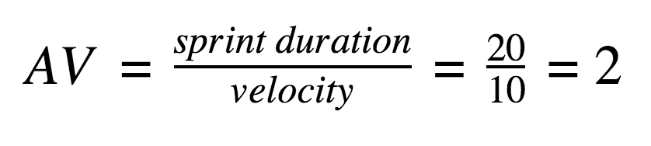

Burndown Chart:
A burn down chart is a graphical representation of work left to do versus time. It is often used in agile software development methodologies such as Scrum. However, burn down charts can be applied to any project containing measurable progress over time.

https://www.visual-paradigm.com/scrum/scrum-burndown-chart/
https://www.atlassian.com/agile/tutorials/burndown-charts

Reference:
https://www.atlassian.com/agile/project-management
https://www.atlassian.com/agile/tutorials/how-to-do-scrum-with-jira-software
https://www.atlassian.com/agile/tutorials/epics
https://www.atlassian.com/agile/tutorials/sprints
https://www.atlassian.com/agile/project-management/estimation
https://www.atlassian.com/agile/tutorials/burndown-charts

